**Week 7-11.React JS-HOL**

**Name-Adi Jain**

**Superset ID- 6390400**

**Hands on**

Create a React Application “eventexamplesapp” to handle various events of the form elements in HTML.

**Code**

**File Name: App.js**

import React, { useState } from 'react';

import './App.css';

import CurrencyConverter from './CurrencyConverter';

function App() {

  const [count, setCount] = useState(0);

  const increment = () => {

    setCount(prev => prev + 1);

    alert("Hello member");

  };

  const decrement = () => {

    setCount(prev => prev - 1);

  };

  const sayWelcome = () => {

    alert("welcome");

  };

  const handleClick = () => {

    alert("I was clicked");

  };

  return (

    <div className="App">

      {/* Green-colored heading */}

      <h1 style={{ color: 'green' }}>Event Examples App</h1>

      <br /><br /><br /><br />

      <h2>Counter: {count}</h2>

      <button onClick={increment}>Increment</button>

      <button onClick={decrement}>Decrement</button>

      <br /><br />

      <button onClick={sayWelcome}>Say Welcome</button>

      <br /><br />

      <button onClick={handleClick}>Click Me</button>

      <br /><br />

      <CurrencyConverter />

    </div>

  );

}

export default App;

**========================================================**

**File Name: App.css**

.App {

  text-align: center;

}

.App-logo {

  height: 40vmin;

  pointer-events: none;

}

@media (prefers-reduced-motion: no-preference) {

  .App-logo {

    animation: App-logo-spin infinite 20s linear;

  }

}

.App-header {

  background-color: #282c34;

  min-height: 100vh;

  display: flex;

  flex-direction: column;

  align-items: center;

  justify-content: center;

  font-size: calc(10px + 2vmin);

  color: white;

}

.App-link {

  color: #61dafb;

}

@keyframes App-logo-spin {

  from {

    transform: rotate(0deg);

  }

  to {

    transform: rotate(360deg);

  }

}

**========================================================**

**File Name: CurrencyConvertor.js**

import React, { useState } from 'react';

function CurrencyConverter() {

  const [euro, setEuro] = useState('');

  const conversionRate = 90; // Example: 1 EUR = 90 INR

  const handleSubmit = (e) => {

    e.preventDefault();

    const euroAmount = parseFloat(euro);

    if (isNaN(euroAmount)) {

      alert("Please enter a valid number.");

      return;

    }

    const inrAmount = euroAmount * conversionRate;

    alert(`${euroAmount} EUR = ₹${inrAmount.toFixed(2)} INR`);

  };

  return (

    <div>

      {/* Green-colored heading */}

      <h2 style={{ color: 'green' }}>Currency Converter</h2>

      <form onSubmit={handleSubmit}>

        <label>

          Euro Amount:

          <input

            type="number"

            value={euro}

            onChange={(e) => setEuro(e.target.value)}

            required

          />

        </label>

        <button type="submit">Convert</button>

      </form>

    </div>

  );

}

export default CurrencyConverter;

**========================================================**

**Output**

**Folder Structure**

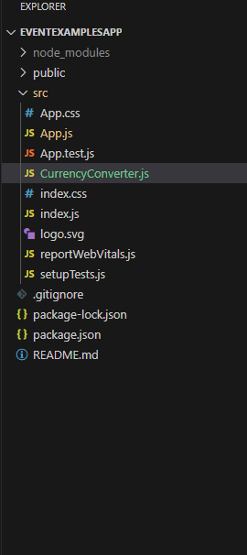

**========================================================**

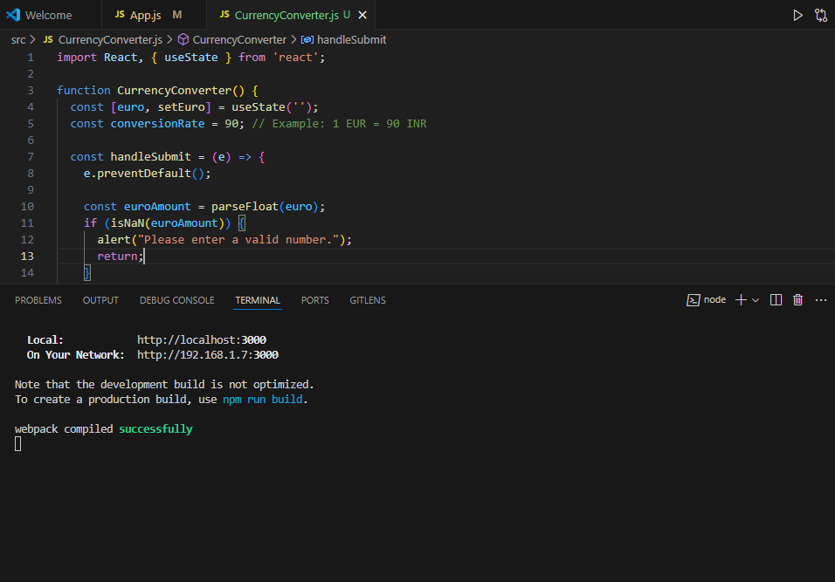

**========================================================**

**When ‘increment’ is clicked**

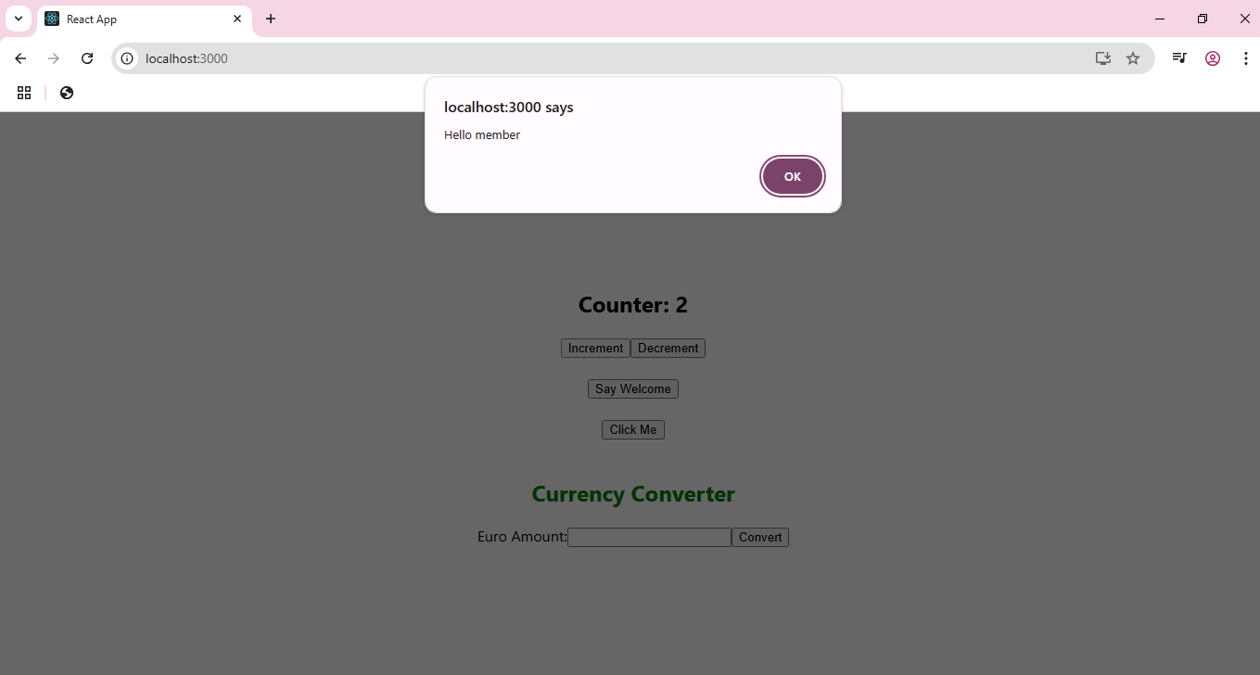

**========================================================**

**When ‘decrement’ is clicked**

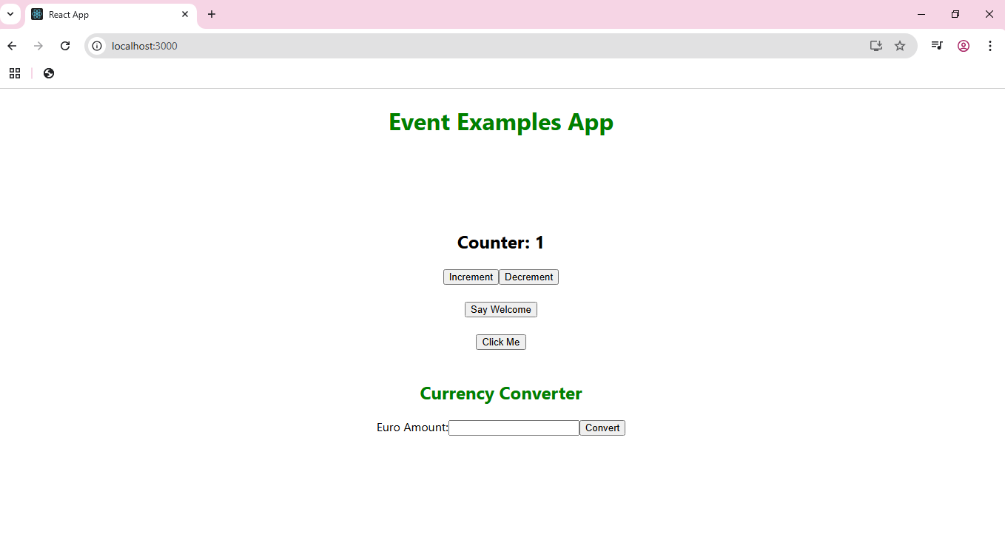

**========================================================**

**When ‘Say Welcome’ is clicked**

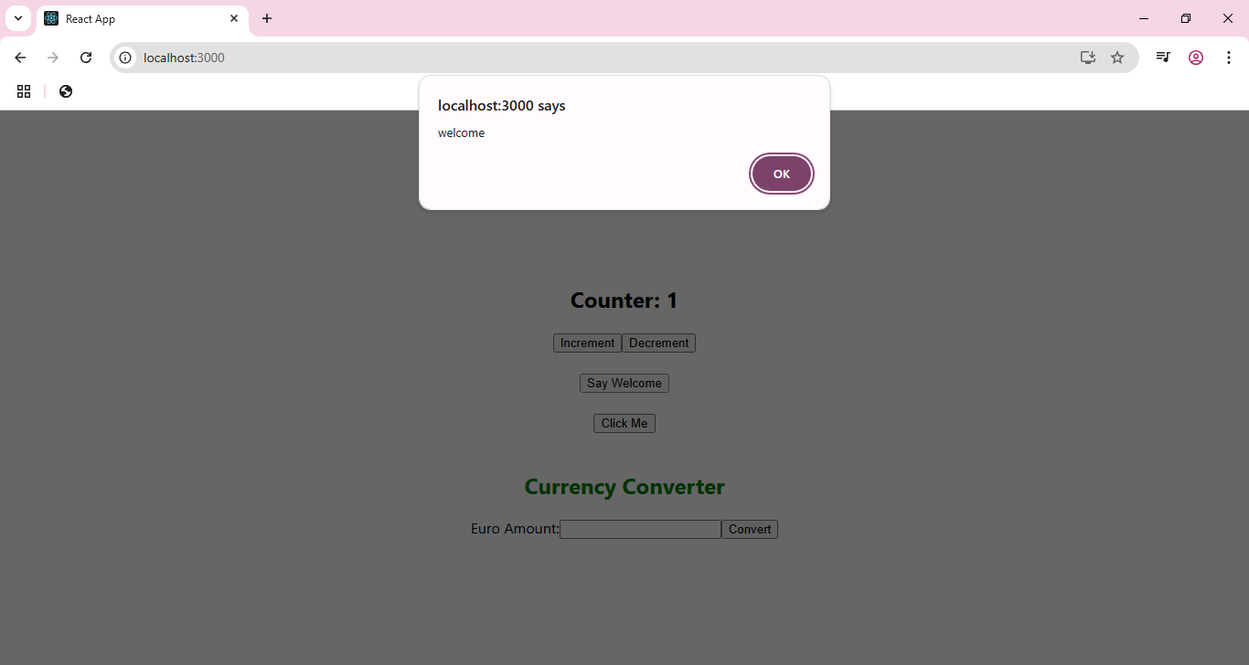

**========================================================**

**When ‘Click Me’ is clicked**

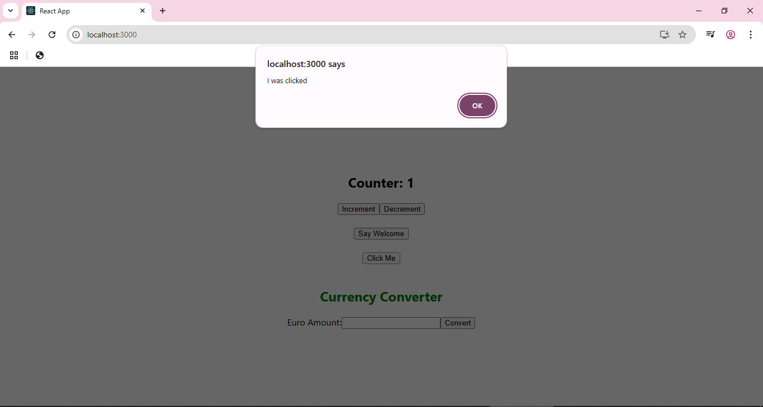

**========================================================**

**Converting currency from euro to INR**



